Extracting Time Components

Definition
# Source: AI Source: Provided by: [Data Path: Persons Table -> ID Column: 1, Name_En Column: Motasem Essam] -> From: [Chatgpt (GPT‑5 Mini)] on [12/10/2025]
Extracting Time Components is a date/time transformation technique where a time or timestamp value is divided into its individual parts such as hour, minute, and second. This helps in analyzing time-based patterns and behaviors in datasets.

Key Idea
# Source: AI Source: Provided by: [Data Path: Persons Table -> ID Column: 1, Name_En Column: Motasem Essam] -> From: [Chatgpt (GPT‑5 Mini)] on [12/10/2025]
A timestamp contains multiple pieces of information. By separating these into individual components, analysts and machine learning models can better understand daily activity patterns and temporal trends.

Common Time Components
# Source: AI Source: Provided by: [Data Path: Persons Table -> ID Column: 1, Name_En Column: Motasem Essam] -> From: [Chatgpt (GPT‑5 Mini)] on [12/10/2025]
Typical components extracted from time or timestamps include:
- Hour – useful for analyzing hourly patterns
- Minute – helpful for detailed time analysis
- Second – used in high-precision datasets
Additional components may include:
- AM/PM indicator
- Time of day category (morning, afternoon, evening, night)

Example
# Source: AI Source: Provided by: [Data Path: Persons Table -> ID Column: 1, Name_En Column: Motasem Essam] -> From: [Chatgpt (GPT‑5 Mini)] on [12/10/2025]
Original dataset:
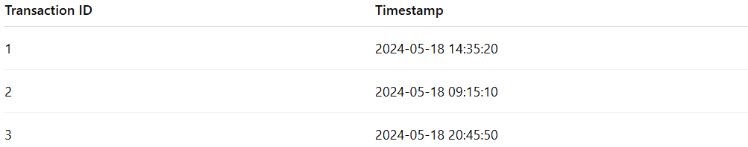
Transaction ID | Timestamp
1 | 2024-05-18 14:35:20
2 | 2024-05-18 09:15:10
3 | 2024-05-18 20:45:50
After extracting time components:
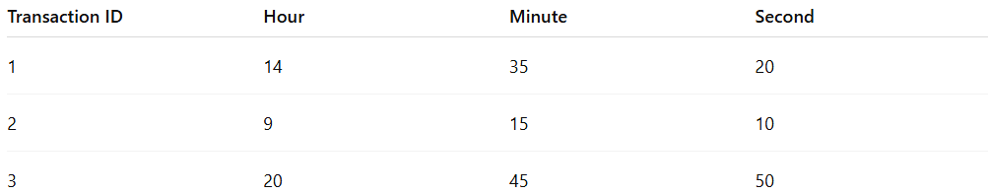
Transaction ID | Hour | Minute | Second
1 | 14 | 35 | 20
2 | 9 | 15 | 10
3 | 20 | 45 | 50

Example with Time Categories
# Source: AI Source: Provided by: [Data Path: Persons Table -> ID Column: 1, Name_En Column: Motasem Essam] -> From: [Chatgpt (GPT‑5 Mini)] on [12/10/2025]
Original timestamp:
Timestamp
2024-05-18 14:35:20
After transformation:
Hour | Minute | Second | Time of Day
14 | 35 | 20 | Afternoon

Advantages
# Source: AI Source: Provided by: [Data Path: Persons Table -> ID Column: 1, Name_En Column: Motasem Essam] -> From: [Chatgpt (GPT‑5 Mini)] on [12/10/2025]
- Helps detect daily usage patterns
- Improves machine learning model performance
- Allows analysis of peak activity times

Disadvantages
# Source: AI Source: Provided by: [Data Path: Persons Table -> ID Column: 1, Name_En Column: Motasem Essam] -> From: [Chatgpt (GPT‑5 Mini)] on [12/10/2025]
- May increase the number of features in the dataset
- Some patterns may require additional temporal feature engineering

